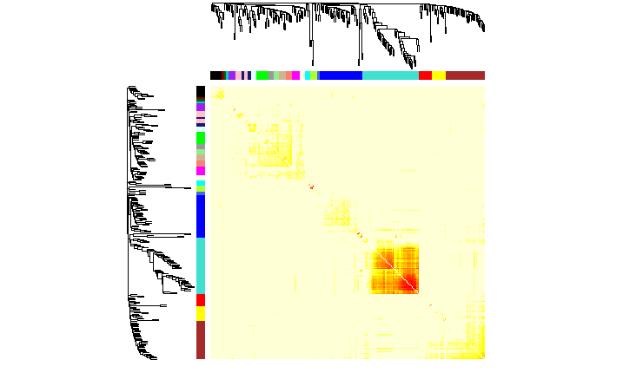

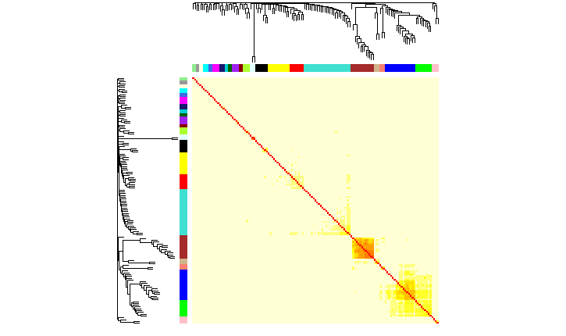

Supplementary Figure 5 – Topological Overlap Matrix plot for WGCNA for a) 2000 and b) 2015 data.